Minnesota Census Partners – With the deadline for 2020 Census responses just a few weeks away, please post frequently to remind people to be counted. Posts here are easy to copy, paste and post.

Thanks in advance for sharing – Mo Schriner

1). Be counted by a census taker
(right-click on this image and select Save As Picture to save to your computer, or elect Copy, then paste directly into a social media post)
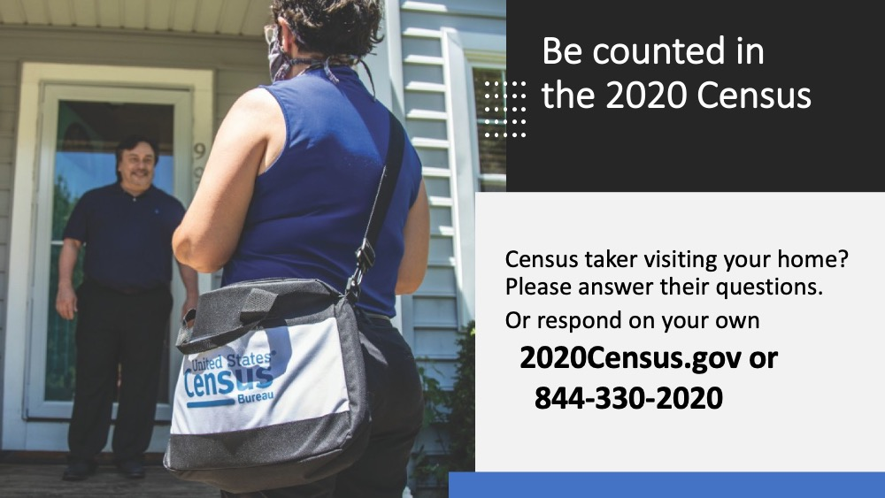

CONTENT to share with census taker image:
Your response to the #2020Census impacts our community for 10 YEARS.
If a census taker visits you, please respond.
You only need to answer a few basic questions.

There’s still time to respond on your own:
2020Census.gov
#WeCountMN

2). Count-down clock!
Share this content with a link to the Census count-down clock
https://www.timeanddate.com/countdown/generic?iso=20200930T115959&p0=159&msg=Deadline+to+respond+to+2020+Census&font=hand

CONTENT to share with count-down clock:
There’s still time to respond to the #2020Census.
But the clock is ticking down.
Go now to 2020Census.gov.
Call 844-330-2020.
#WeCountMN

3) Your Response is Crucial video
https://www.youtube.com/watch?v=IKgsapDbYn8
(to share on social media - click link, then click lower right “share” icon)

CONTENT to post with video:
Be counted in the #2020Census.
Tell your family, friends and neighbors,
EVERYONE in Minnesota counts in the census.

Go now to my2020Census.gov or call 844-330-2020.
#WeCountMN

4) SPANISH language video post - A Story about Carl
https://www.youtube.com/watch?v=et3lRxmn8kQ
(to share on social media - click link, then click lower right “share” icon)

CONTENT to post with video:
No seas un fantasma.
Ser contados.
Responder al censo de 2020.
2020Census.gov/es
844-468-2020
#WeCountMN

5) “Be Counted” post with animated GIF
To include this animated GIF in a post - right-click on this image and select Save As Picture to save to your computer; THEN create a social media post and add the picture from your computer. (if you copy and paste the graphic, the animation will be lost)

CONTENT to post with GIF:
Have you been counted in the #2020Census?
It’s not too late. Count everyone who lives with you.
It’s IMPORTANT – results of the census will impact the next 10 years for our community’s govt representation and funding.
2020Census.gov
#WeCountMN

6) “How to complete the census online” post with animated GIF
To include this animated GIF in a post - right-click on this image and select Save As Picture to save to your computer; THEN create a social media post and add the picture from your computer. (if you copy and paste the graphic, the animation will be lost)

CONTENT to post with GIF:
Did you get a notice at your house about a visit by a census taker to complete the #2020Census? Take 10 minutes now to impact the next 10 years.
Visit 2020Census.gov to respond online today.

It’s easy, it’s safe and it’s IMPORTANT.
#WeCountMN

