# *Blandin Broadband Communities Program*

**Initial Steering Committee Meeting**

### OUTCOMES

**By the end of this session, we will have…**

* **Gotten to know our fellow coalition members and their leadership styles**
* **Identified connections we bring to our group and the role that we will play**
* **Identified who needs to be engaged in the BBC planning process**
* **Identified how we are going to have a successful Vision Meeting**

### PROCESS

|  |  |  |
| --- | --- | --- |
| **0:00** |  | **Welcome and Introductions – *Chair*** |
| **0:05** |  | **Review Agenda and Meeting Outcomes** |
| **0:10** |  | **Intro to the Blandin Broadband Communities Program** |
| **0:30** |  | **Role of the Steering Committee** |
| **0:50** |  | **Leadership Styles of our Coalition and community connections** |
| **1:20** |  | **The Vision Meeting**  **Logistics and invitations – Community leadership and Inclusion** |
| **1:40** |  | **Applying for the Blandin Grant** |
| **2:00** |  | **Next Steps, Wrap up, and Evaluation– Adjourn** |

**Blandin Team**

Primary Contact:

Bill Coleman, Community Technology Advisors

651-491-2551

[bill@communitytechnologyadvisors.com](mailto:bill@communitytechnologyadvisors.com)

Primary Grants Contact:

Mary Magnuson, Blandin Foundation

218-327-8738

[memagnuson@blandinfoundation.org](mailto:memagnuson@blandinfoundation.org)

Bernadine Joselyn, Blandin Foundation

Director, Public Policy and Engagement

218-327-8728

[brjoselyn@blandinfoundation.org](mailto:brjoselyn@blandinfoundation.org)

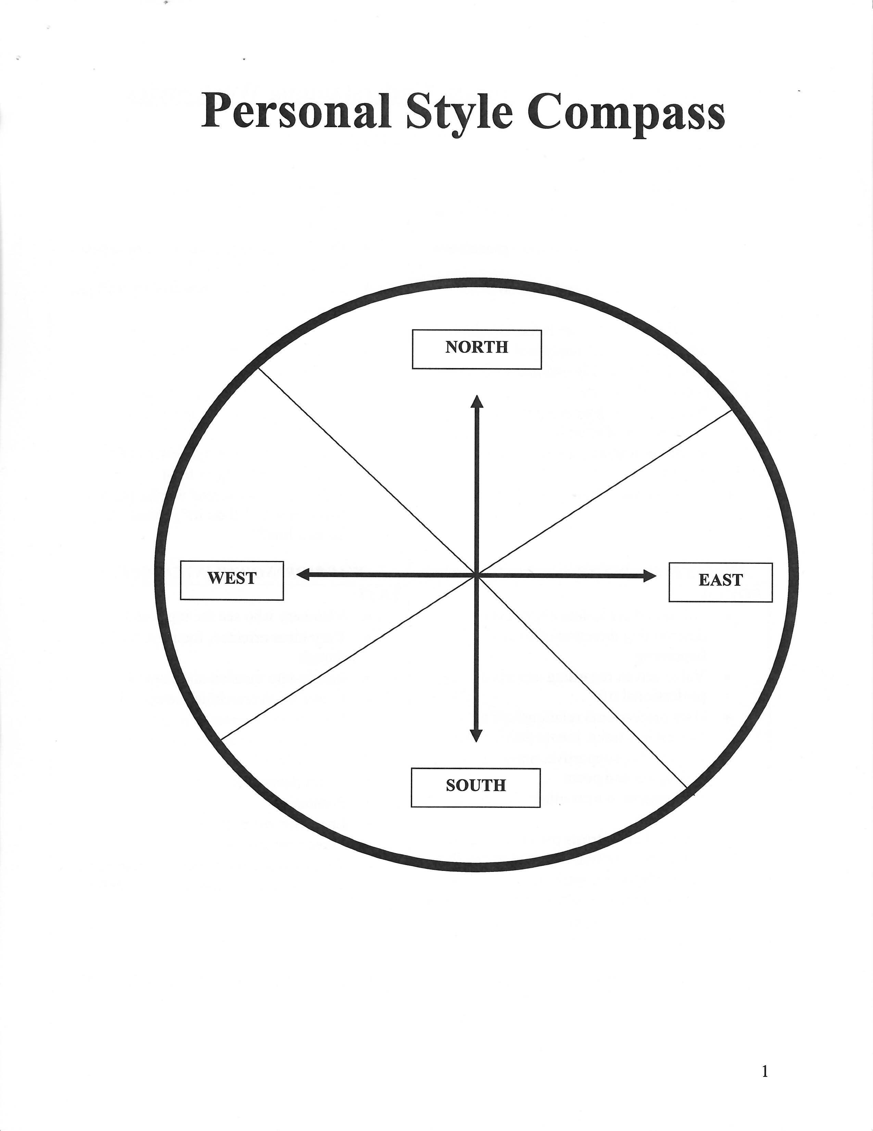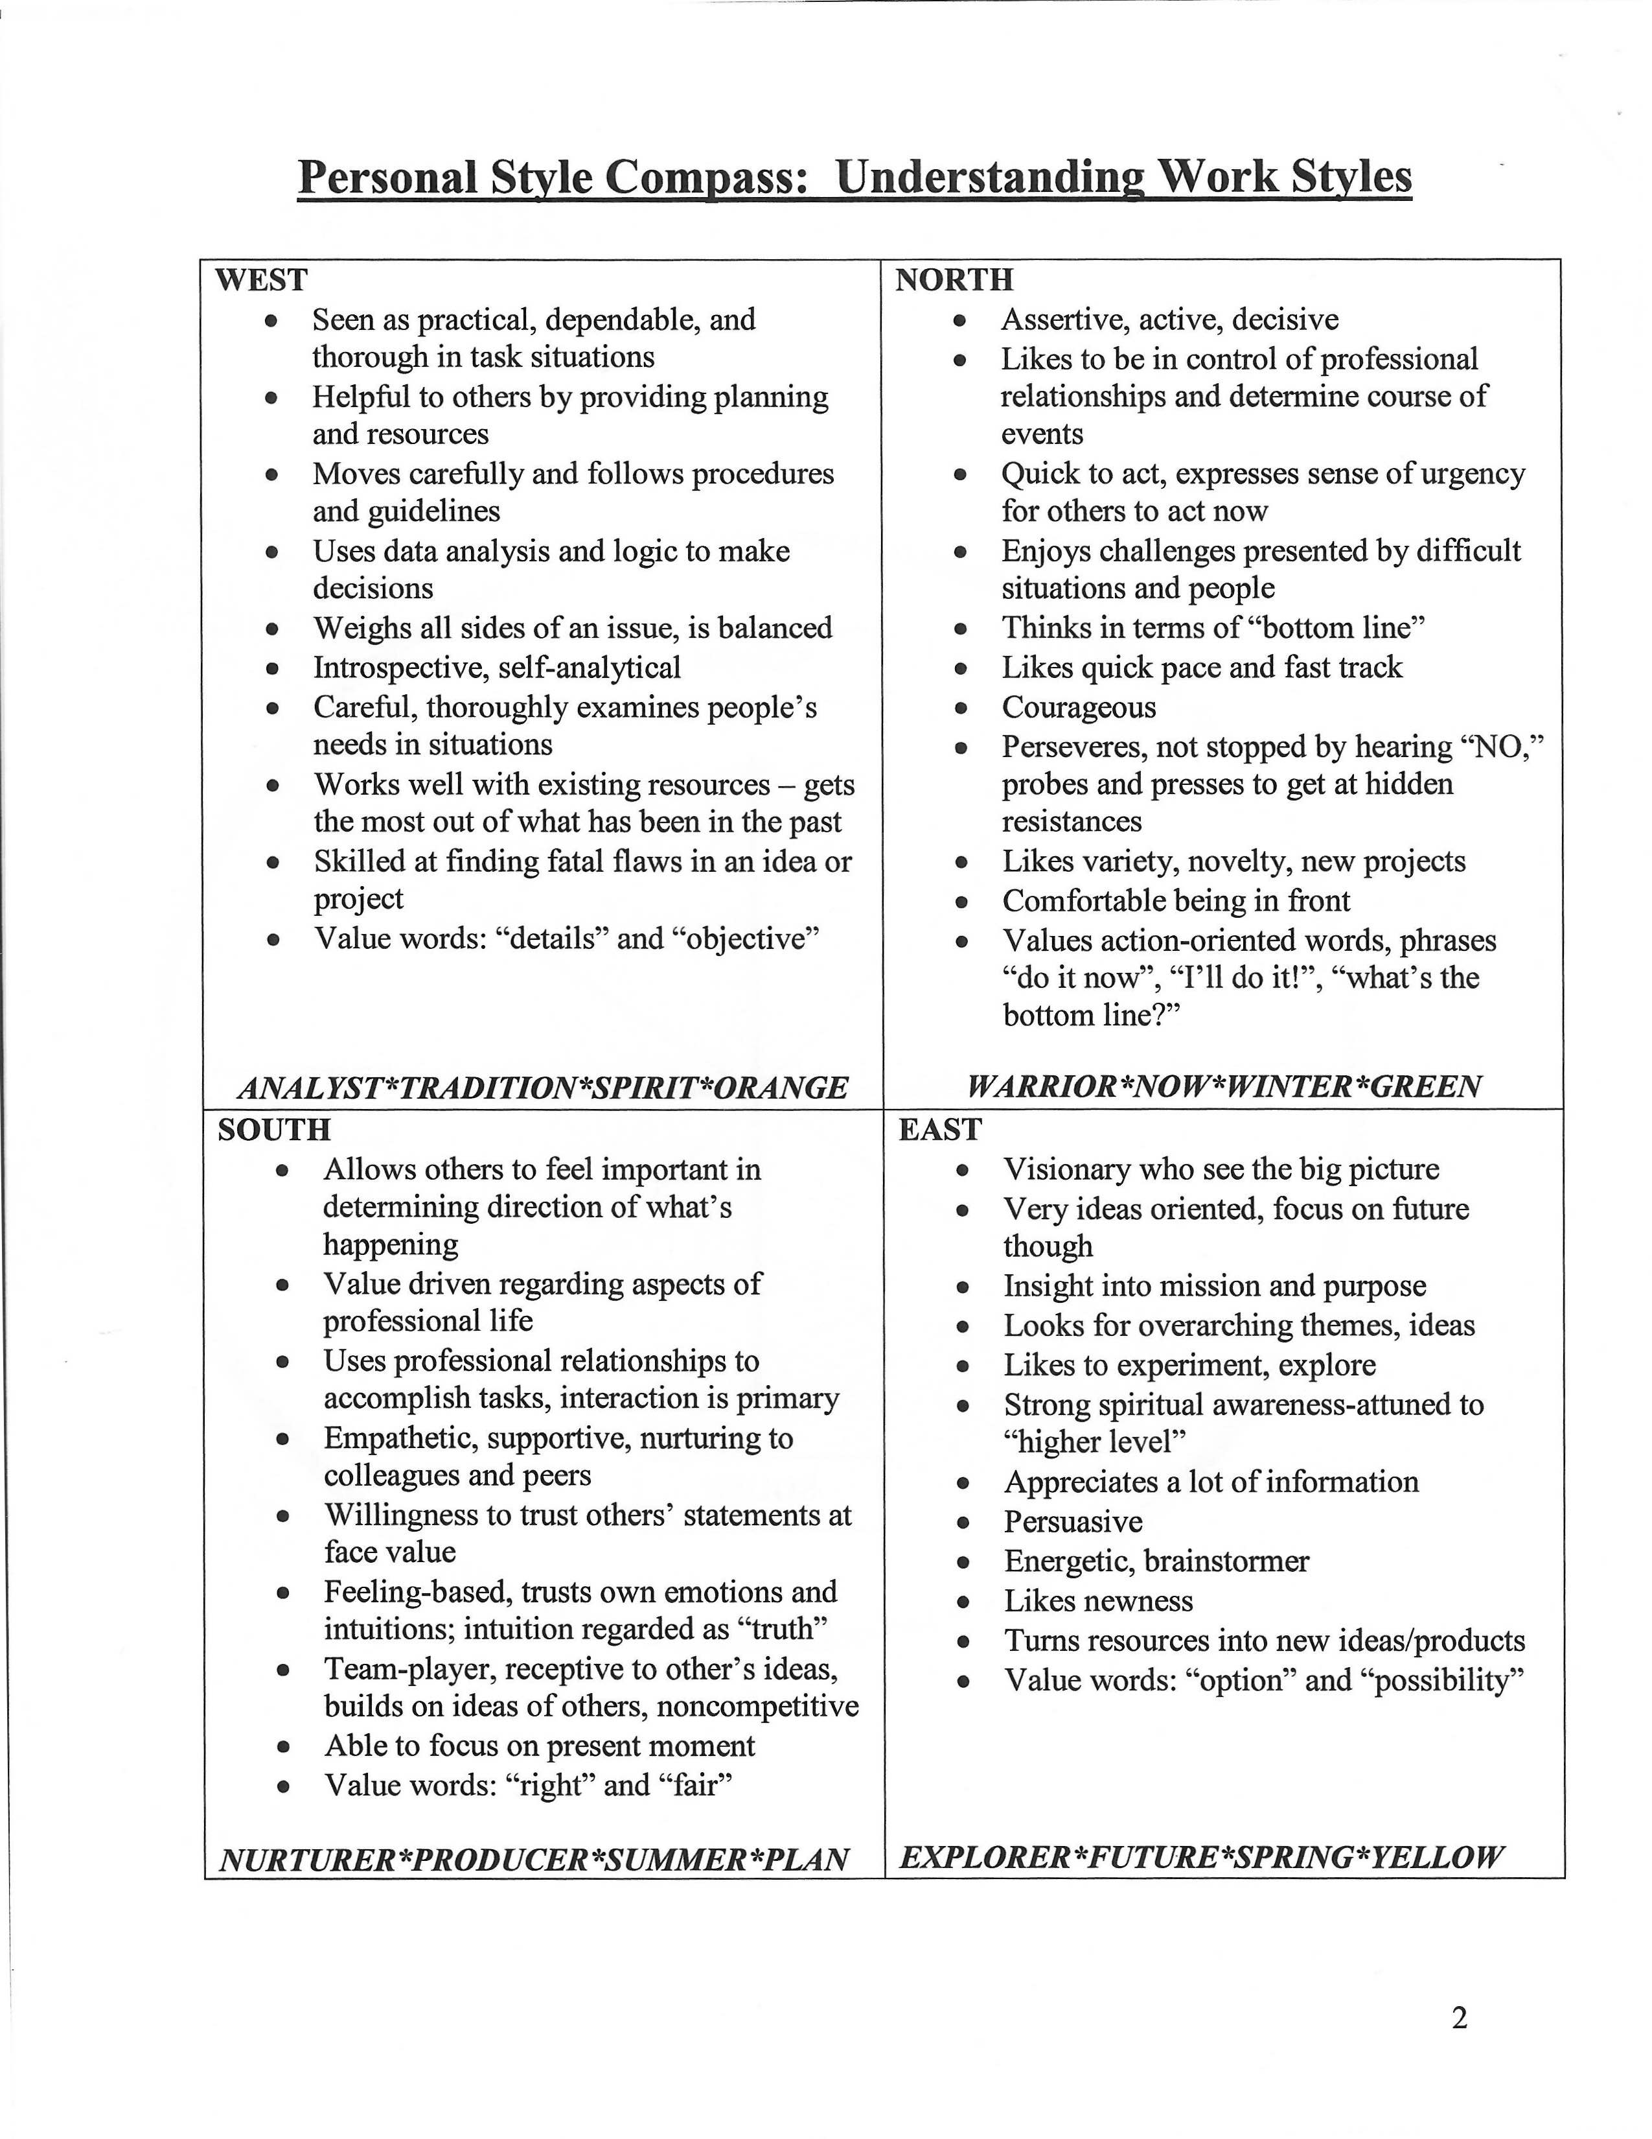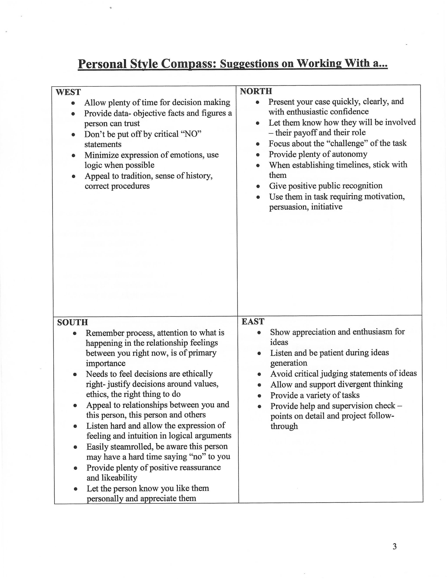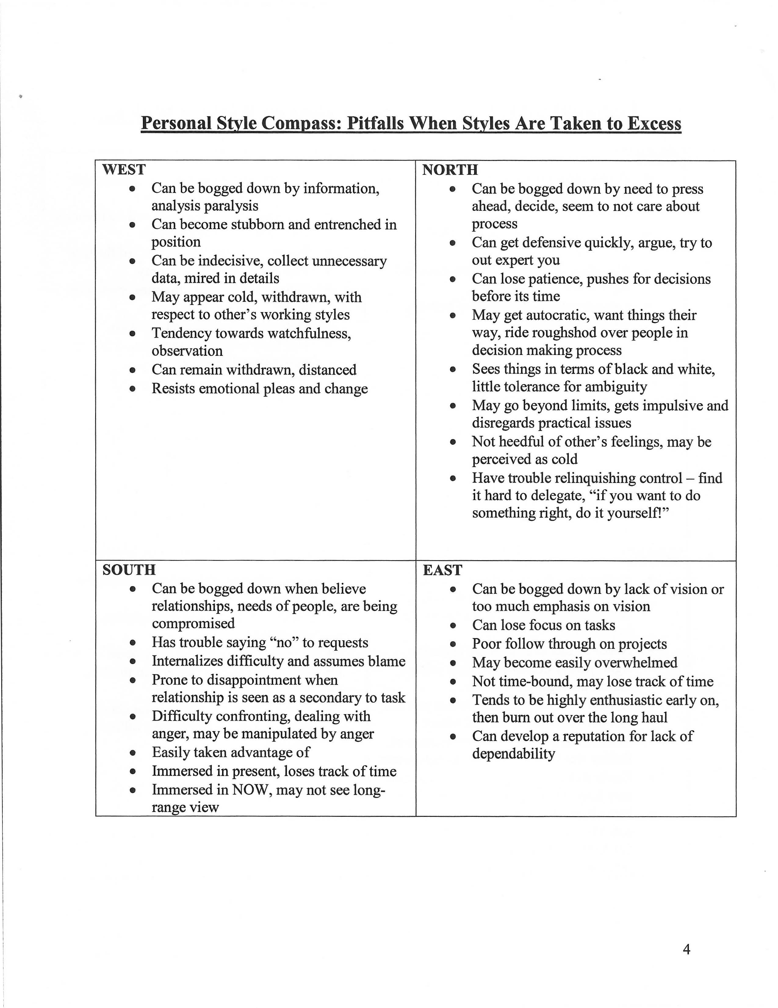

**My working styles is:**

**Gifts that I can bring to our effort include:**

**Special knowledge that I have:**

**Connection that I can bring to our efforts:**

**Creating a Successful Vision Meeting**

**“Getting the Right People in the Room”**

|  |  |  |  |
| --- | --- | --- | --- |
| **Group** | **Key Individual** | **Who Will Contact?** | **Notes** |
| **Education** |  |  |  |
| K-12 |  |  |  |
| Private |  |  |  |
| College |  |  |  |
|  |  |  |  |
| **Government** |  |  |  |
| Local |  |  |  |
| County |  |  |  |
| Region |  |  |  |
|  |  |  |  |
|  |  |  |  |
| **Business** |  |  |  |
| Chamber |  |  |  |
| Key businesses |  |  |  |
|  |  |  |  |
|  |  |  |  |
| Tech businesses |  |  |  |
|  |  |  |  |
|  |  |  |  |
|  |  |  |  |
| **Health Systems** |  |  |  |
|  |  |  |  |
|  |  |  |  |
| **Key Audiences** |  |  |  |
| Older adults |  |  |  |
|  |  |  |  |
| Youth |  |  |  |
|  |  |  |  |
| New Americans |  |  |  |
|  |  |  |  |
| People with Disabilities |  |  |  |
|  |  |  |  |
|  |  |  |  |
| Job Programs |  |  |  |
|  |  |  |  |
| Veterans |  |  |  |
|  |  |  |  |
| **Logistics** |  |  |  |
| Facility |  |  |  |
| Refreshments |  |  |  |
| Media/Newspaper |  |  |  |
| Social Media/Web |  |  |  |
|  |  |  |  |
|  |  |  |  |

*Revised 5/27/20*

**Draft Email Invitation to Blandin Broadband Community Vision Meeting**

[Insert Greeting],

Vibrant and smart rural communities are connected communities. Abundant and robust access to the Internet, and the skills necessary to take full advantage of this access, are essential as [insert community name] seeks to compete and thrive in an ever more connected world.

We are excited to announce that we have been selected as a Blandin Broadband Community. This program will give us access to coaching, planning assistance and a chance to obtain financial resources that will positively affect our community. With the COVID-19 situation, Blandin Foundation has moved this entire process online. We need your voice in this process that is just getting underway.

This is about more than broadband. It is about our workforce, digital inclusion, innovation, sustainability and marketing. It is about our community as a whole and individual organizations and people. You don’t have to be a techie to be a contributor to our initiative.

I invite you to participate in our online process that begins with an online survey, followed by two Zoom meetings and an online voting process. There will be an opportunity to suggest how our community allocates $75,000 for technology projects, and even better, to volunteer to participate in these efforts. Complete the survey by clicking here ____________. At the end of the survey, you can register for the Community Vision and/or the Brainstorm meetings on DATES, respectively. Project voting will take place shortly after the Brainstorm meeting. Come add your voice and energy as we build the path to a highly-connected [insert community name].

We hope to see you online!

**Draft Script for BBC Phone Conversations**

**Goal: Build Will. Audience should already know that broadband access and use is beneficial for your community. Help them see potential solutions and how they can help build toward it.**

**Advice:**

1) Personalize the concern by linking it to something observable in your community. *How* do you know that this is a legitimate community concern? Concern emphasizes the problem that needs solving. You can also use “focus” if concern sounds too negative.

2) If you have a specific example/solution you can give from your community – use it! If not, share a solution from another rural MN community and past BBC.

**………..**

Hi, I wanted to reach out to you about some exciting work happening in our community around Internet access and use. ***(If “access and use” sounds too formal, replace with something more tangible like “exciting work to get more people and places hooked up to and using the Internet and all that it offers.” )***

As the world becomes more connected, it’s important that [City/County] does everything we can to make sure our community doesn’t fall behind. You might have seen in the paper that [City/County] was named a Blandin Broadband Community and we now have the chance to develop a strategy and a series of projects that help move our community into the future, with help of up to $75,000 in grant dollars.

**\*Select one topical paragraph based on knowledge of your contact’s community and personal interests**

For example, we know from {past community conversations, research, inquiries} that our schools are a priority for [City/County] residents. As schools learn how to best integrate technology into the classrooms, we also need to prepare our young people for careers where knowledge of technology is vital. Fond du Lac, a past Blandin Broadband Community, held an application development camp to introduce students to computer programming and also carried out a 1-to-1 mobile device program in the schools.

--

For example, we know from {past community conversations, research, inquiries} that healthcare is critically important to [City/County] residents. In our rural community, it’s not always easy or possible to make the drive to the nearest clinic or hospital. Kanabec County, a past Blandin Broadband Community, supported a partnership that used telehealth technology to provide pre-surgical patient education.

--

For example, we know from {past community conversations, research, inquiries} that the strength of our local business community is a primary concern for [City/County] residents. Our businesses are a cornerstone of our economy and it’s important we offer the resources and training they need to stay competitive. Itasca County, a past Blandin Broadband Community, focused all their broadband efforts on their local business community by creating a process where businesses worked with a consultant to assess how they were currently utilizing the Internet to promote and run their business. Those businesses were then able to access funds and training to enhance their knowledge based on recommendations.

--

For example, we know from {past community conversations, research, inquiries} that connecting all generations is a primary concern for [City/County] residents. Seniors in our community want to stay connected – to what’s going on in [City/County] and with their families. Lake County, a past Blandin Broadband Community, has developed a number of ways to get seniors connected. One was classes that brought together high school seniors and senior citizens to learn various things, like how to Skype with family, how to search for, and buy, items they need online. All things that can enhance seniors’ quality of life by keeping them connected to the people they care about and the information and things they need.

--

**The Ask**

And this is just one example. Projects could focus on healthcare, education, local business, seniors in our community, or any mix of them! Due to COVID-19, we are doing this entire process online – using surveys and Zoom meetings to gather input and ideas. I will send you the survey and meeting registration links via email or you can go online to >>>>>>>>>> and get started there.

I hope that you decide to participate. You have an important voice in our community.

[Organization Logo]

FOR IMMEDIATE RELEASE

**Community invited to attend planning meeting for future Internet projects**

[CITY], Minn. (DATE) – [Calling organization] invites the public to participate in our Blandin Broadband Community Vision and Brainstorm meetings where priorities will be determined, and projects developed to improve Internet access and use in [City/County].

[City/County] was named one of five new Blandin Broadband Communities (BBC) in January. The BBC program provides planning, technical and financial support to communities that demonstrate the determination to bring the benefits of a broadband-enabled economy to their communities. The new communities will each have access to a $75,000 grant, but projects will have to meet Blandin Foundation standards in order to be funded. Successful projects in other communities have focused business technology websites and incubators, technology camps for school kids, online job training, and community marketing.

Due to COVID-19, Blandin Foundation has revised this program to be completely online. The process will use a combination of surveys and Zoom meetings to set goals and develop projects rather than the more traditional on-site process that Blandin Foundation has used in 40 other communities over the years. To participate, residents should go online to: (web link) to complete an initial community survey. They can then choose to register for one or both of the two online interactive meetings. The Vision meeting will be (date/time) with the follow-up Brainstorm meeting on (date/time). Following the online meetings, community members will have a chance through a follow-up community survey to vote for and even volunteer for project teams to be led by various community organizations.

The project is sponsored by (local organization(s). (*Add background info on the organization or recent broadband efforts in your community, then a*dd a quote about the value of the program and the excitement to get the community involved}

###

*\*Add background info on the organization or recent broadband efforts in your community.*

Media contact

[Add information]