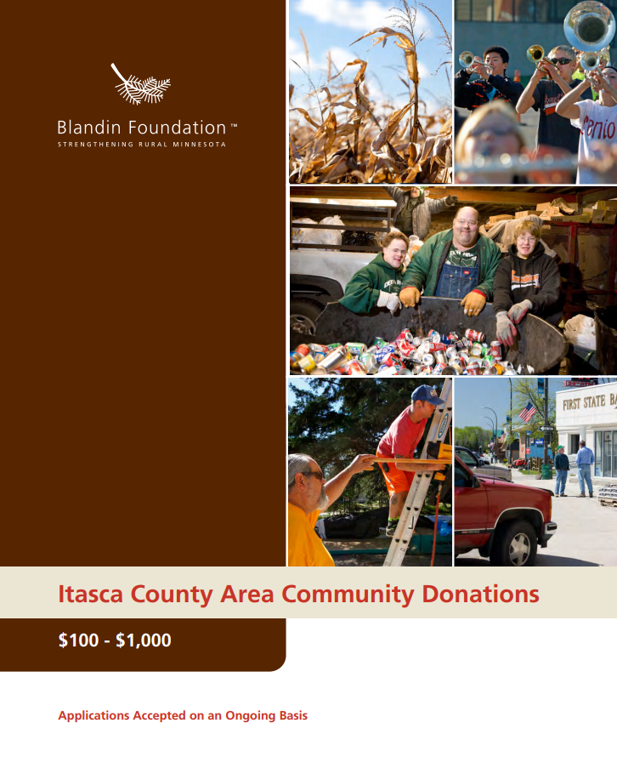

Donations $100 to $1,000
Blandin Foundation does not accept unsolicited proposals. Submit an online inquiry to be considered for a grant.

Organization Information
______________________________________ ______________________________________
Name of organization Name on articles of incorporation, if different _________________________ __________________________ ________________________________
Address City, State, Zip Employer Identification Number (EIN)
__________________________ __________________________ _______________________________
Phone Fax Website
_________________________________ ___________________ _____________ ___________________

Name of Executive Director, CEO, Title Phone E-mail
Board Chair, or Lead Organizer

_________________________________ ___________________ _____________ ___________________
Name of contact person regarding Title Phone E-mail
this application

Is your organization an IRS 501(c)(3) nonprofit? ☐ Yes ☐ No
If no, is your organization a public agency, tribal government entity, or unit of government?
☐ Yes ☐ No
If no, list name and address of fiscal agent, including EIN number: ___________________________________________ ________________________________
EIN Number
If working through a fiscal agent, please attach an email or letter confirming they have agreed to be fiscal agent for your organization.
Anti-Discrimination Policy*
Blandin Foundation does not discriminate on the basis of race, color, religion (creed), gender identity, gender expression, age, national origin (ancestry), disability, marital status, familial status, sexual orientation, sex, pregnancy, military status, or any other legally protected status or characteristic in its activities or operations.
Blandin Foundation does not knowingly award grants to organizations that violate our anti-discrimination values. If at any point in a working relationship Blandin Foundation discovers standards, policies, or practices held by any of our partners that violate this anti-discrimination policy, Blandin Foundation reserves the right to terminate the relationship, contract, and/or ask for funds to be returned to the Foundation to the extent permissible by law, in addition to Blandin Foundation’s cessation of business with that organization or entity in the future.
Does your organization, project, or initiative comply with our Anti-Discrimination Policy?
☐ Yes ☐ No *Excerpt, view Blandin Foundation’s full Anti-Discrimination Policy here.
Proposal Summary
Duration of project: ____________________________ to ______________________________
Please give a 2-3 sentence summary of your proposal:

Please give a 1-2 sentence summary of the geographic area your proposal will serve:

Please give a 1-2 sentence summary of how your board and staff are representative of the population you serve.

Budget Summary
Fiscal Year of Organization or Project: ____________________ to ______________________
Total project budget: $
Total dollar amount requested of Blandin Foundation: $
Total annual budget (organization, division, or program): $

Signature
_____________________________________________________________________________________ Name of CEO/Executive Director or Board Chair
_____________________________________________________________________________________Signature (scanned/electronic signature acceptable)

