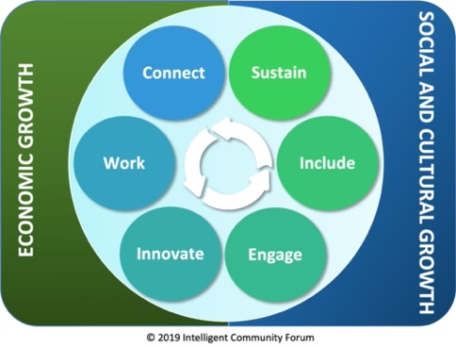
ICF Quick Benchmarking

Community Name:

Please answer these questions for your community for each element.
(Three minutes per element).
1) Which people/organizations are working on this element?
2) What activities are underway?
3) How would you rate the intensity of effort? 5 = high 1 = low

Broadband (Connect)
People/Organizations:
Activities:
Rating:
Other:

Knowledge Work (Work)
People/Organizations:
Activities:
Rating:
Other:

Innovation (Innovate)
People/Organizations:
Activities:
Rating:
Other:

Digital Equality (Include)
People/Organizations:
Activities:
Rating:
Other:

Sustainability (Sustain)
People/Organizations:
Activities:
Rating:
Other:

Community Engagement (Engage)
People/Organizations:
Activities:
Rating:
Other:

