Blandin Broadband Communities
Intelligent Community Self-Assessment

Community Name:
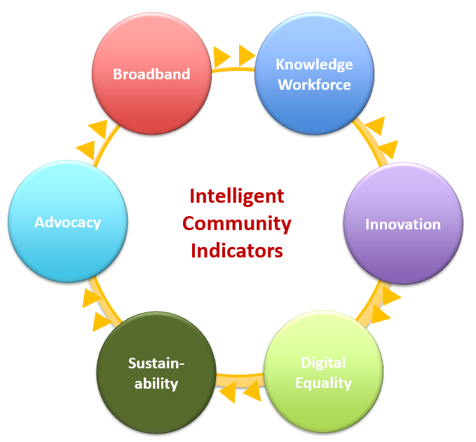

Broadband

Generally, how well is your community served with broadband - in towns and across the entire community?

To what degree, if any, do educational institutions, the public sector and health care organizations in your area use broadband to deliver services? How do they connect? Is the broadband available in your area adequate to meet their needs?

What is the state of wireless services in your community?

Where are the wireless hot spots? Are they available to community members?

Have you engaged in conversation with existing and/or prospective broadband providers to identify their plans and discuss potential partnerships?

Knowledge Workers

Describe the "state of the workforce" in your community.

Where are the workforce gaps? In high-skill, high wage positions, qualified manufacturing workforce, or basic skills?

What assets do you have for improving your supply of knowledge workers?

Have you had convened discussions with K-12 and higher education leaders with employers, either generally or with specific industry sectors, to discuss partnerships to improved workforce assets?

Innovation

When you look at organizations and technology practices in your community, in what areas can you say, "we are really doing great things with technology?" Conversely, where are you not keeping up? Which sectors need improvement?

What is your community doing to support entrepreneurs and spur the creation of new business enterprises?

How is your community being thoughtful about and actively grappling with a changing economy, demographics or other trends?

Digital Equality

In your community, is digital equality a matter of broadband availability, awareness, language and/or affordability?

What efforts are underway in your region to address digital equality?

Who might be your best partners in working to address digital equality gaps?

Sustainability

Is sustainability on the agenda in your community as a priority and seen as a driving force? How is the community engaged on this topic, as demonstrated by the presence of one or more groups focusing on sustainability, construction of LEED-certified buildings or through passage of goals, resolutions or land use plans by local units of government?

Do you have any local businesses or higher education programs that focus on helping other organizations become more sustainable as a strategic business objective? This might include providing energy audits, manufacturing sustainable products, facilitating or documenting sustainable supply chains

Do you have any companies engaged in delivering sustainability products and services as a primary focus of their business?

Is there any effort to measure and reduce the solid waste, energy and water consumption, or other natural resources within community organizations or community-wide?

Advocacy

Which organizations are active in external marketing efforts to attract people and investment to the community? What image or images are presented and how well? Is there any coordination across entities?

Which organizations market to existing community members? What content are they delivering and how? Are their opportunities for collaboration? Unified messaging around broadband and the other Intelligent Community elements?

Summary

On a scale of 1 – 5 with 5 being high, please indicate how important improving each of the six Intelligent Community indicators are to the future of your community. Then indicate the current energy level of your community around this issue.

Importance Energy

Broadband
________________________________ ________________________________
1 2 3 4 5 1 2 3 4 5

Knowledge Workforce
________________________________ ________________________________
1 2 3 4 5 1 2 3 4 5

Innovation
________________________________ ________________________________
1 2 3 4 5 1 2 3 4 5

Digital Equality
________________________________ ________________________________
1 2 3 4 5 1 2 3 4 5

Sustainability
________________________________ ________________________________
1 2 3 4 5 1 2 3 4 5

Advocacy
________________________________ ________________________________
1 2 3 4 5 1 2 3 4 5

