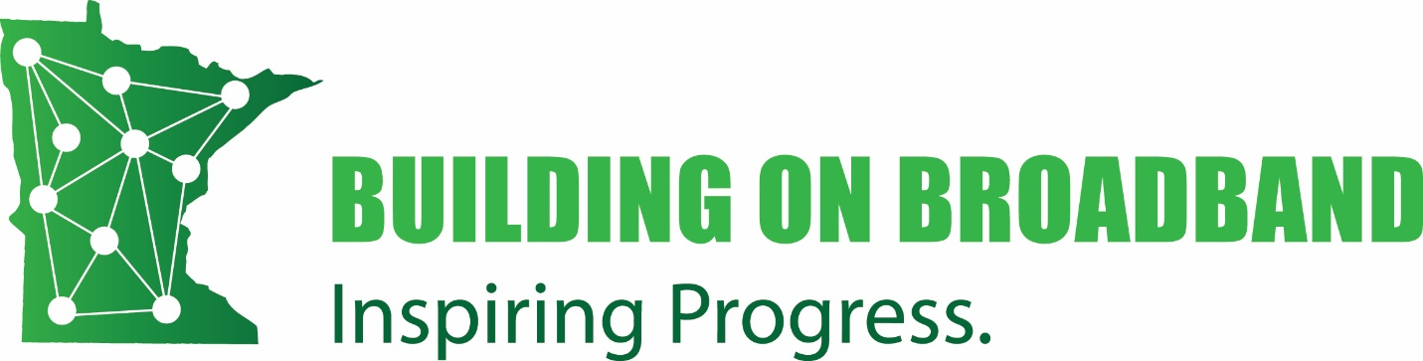
State-wide virtual broadband conference
October 12-14, 2021

Request for Proposals
This RFP serves to identify session ideas for our 2021 virtual broadband conference, Building on Broadband: Inspiring Progress. Planners anticipate up to six hours of content to be filled via this RFP.

Theme and Parameters
Session ideas should relate to the 2021 conference theme of inspiration. With the expected influx of federal funding in 2021, Minnesota is poised to make some progress in addressing the broadband gap:
- What inspires you to keep working toward better, more affordable, connectivity in your community?
- How has your community put broadband to work to help ensure a bright, technologically-enabled future for everyone?
- What can you share to inspire others to keep going?

We encourage proposals that foster storytelling, creativity, innovation, and interaction over a lecture-format. Submissions may include, but are not limited to:
- A short video (30 seconds to 3 minutes) about why broadband is important or how your community is benefiting from broadband or suffering for the lack of it. (Encourage your neighboring communities to do one too and maybe we can have a film-fest!)
- Give an original TED-type talk
- Give a live tour of a facility or demo software
- Suggest a keynote speaker you would like planners to consider inviting
- Suggest a panel topic, and panelists
- Topic for a discussion group; either full group or part of a breakout conversations
- Pick a person to challenge to a debate
- Ask a good question – we will post online for people to answer
- Suggest or host a fun social hour activity
- Trivia – individual questions or set of questions welcome

Sessions with a perceived commercial agenda will not be considered. Speakers should not promote their own products, books, or businesses, or those of a company which employs them. Sessions can only feature technology, product demos, or books that inform an idea presented in a session.

Notification
Your input is valued and will be carefully considered by Building on Broadband: Inspiring Progress planners. If you are volunteering to present on a topic, we will let you know if your session is accepted within a month of submission.

Deadline and Instructions
RFPs are due Friday, August 6.
To submit a proposal, fill out this form https://forms.gle/vs7i95h4cWBoYYQC7 or email the completed submission form to Mary Magnuson at memagnuson@blandinfoundation.org.

Submission form
  - Your name and contact info:

  - Choose one:
___ I volunteer to plan/present this session
___ I will submit a short video
___ Social activity / trivia question(s)
___ I would like to learn about this topic and am suggesting planners consider planning a
session to address it

  - Session description/idea (please be concise, but fully explain the idea, key or intended learning, suggested format, etc.):

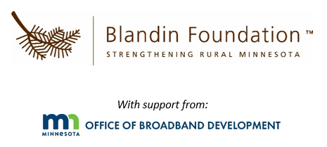
To learn more, visit the conference website. If you have any questions about this RFP,
contact Mary Magnuson at memagnuson@blandinfoundation.org.

