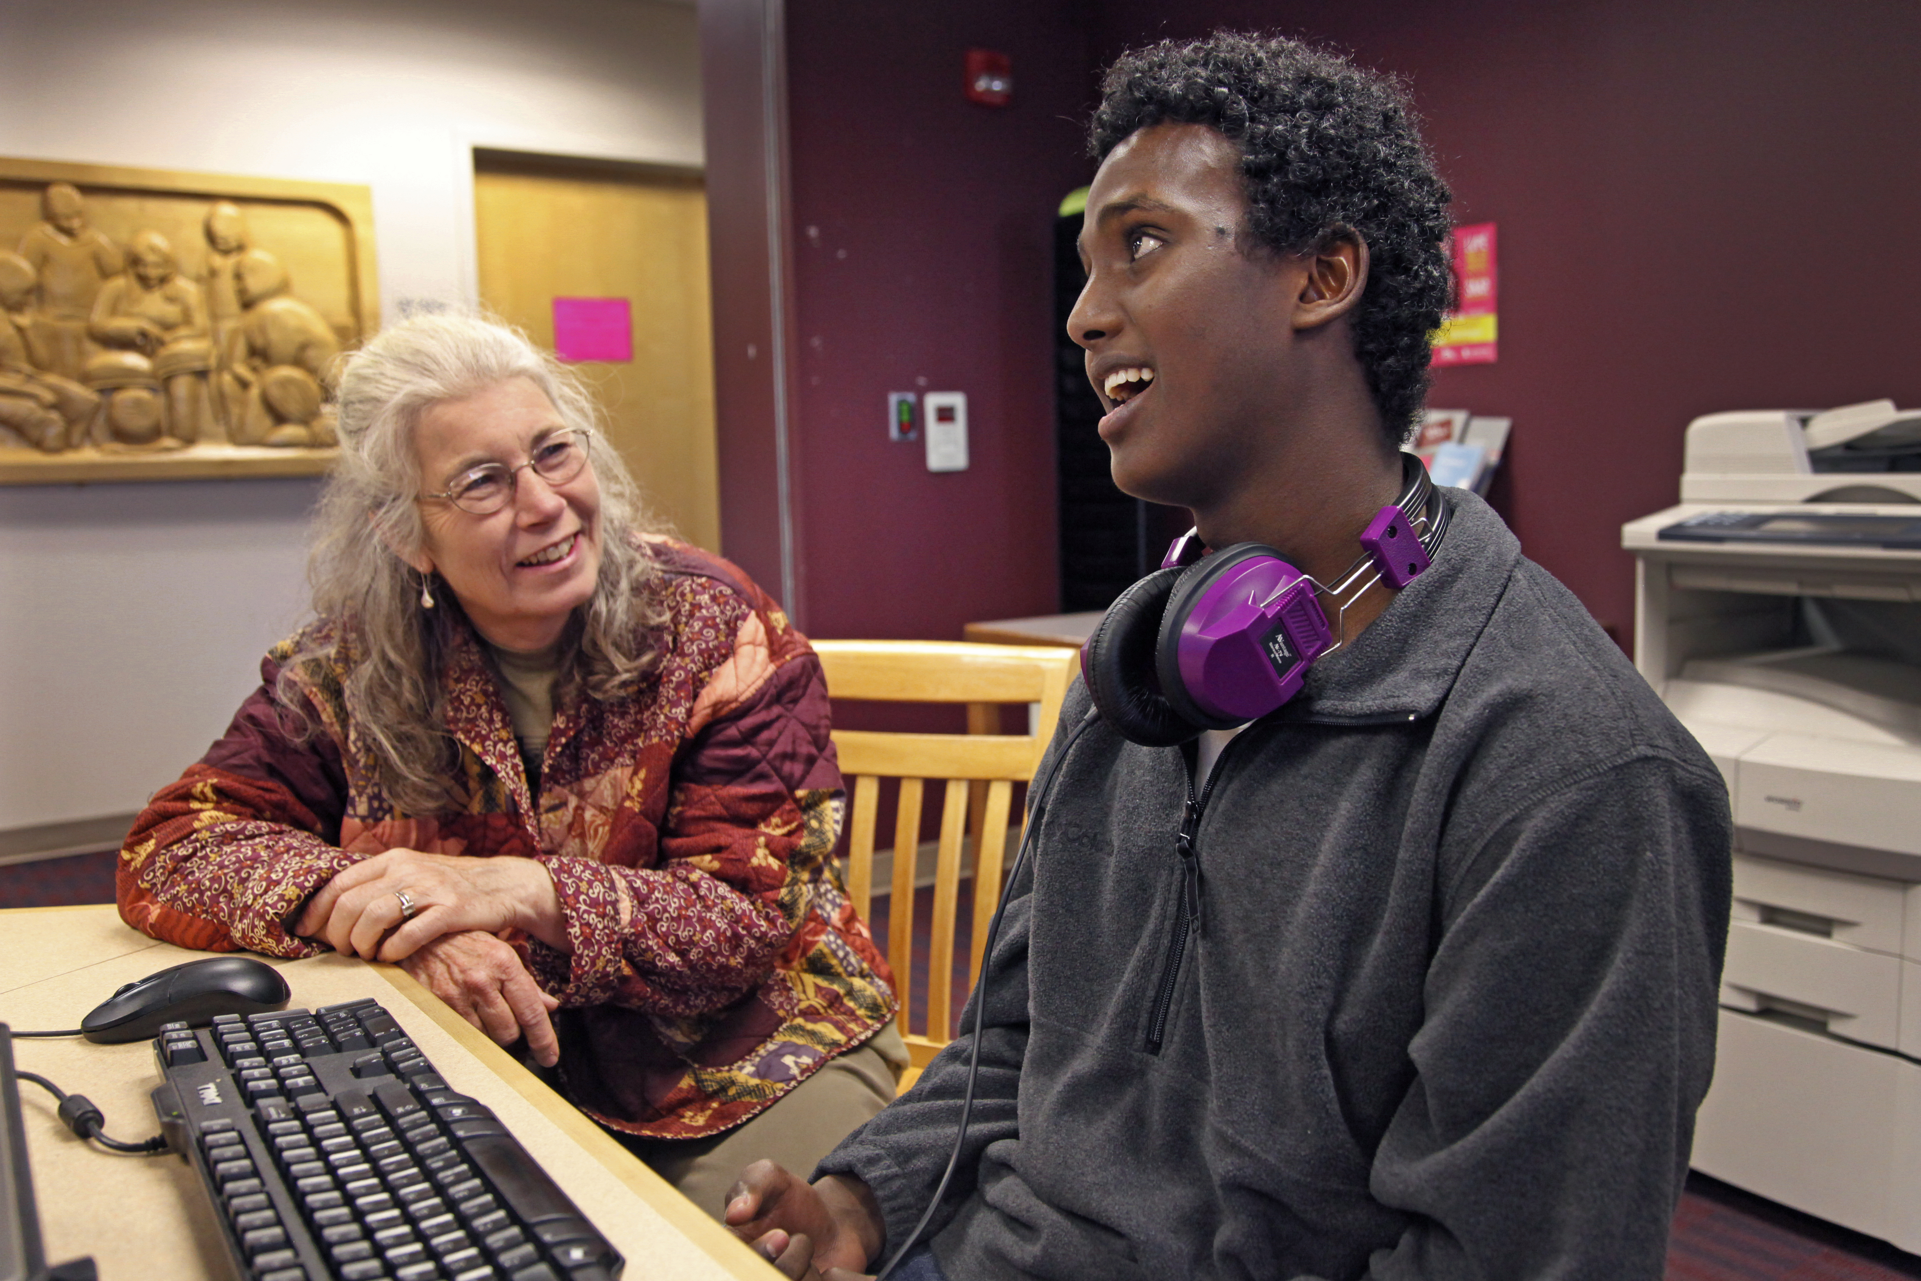
[optional: switch photo to personalize to school/school district]

Finding the Broadband Internet Service That Works for Your Family

A guide provided by [insert school/school district]

[insert logo]

2017

This sample guide was created by Bill Coleman of Community Technology Advisors and is provided by the Blandin Foundation as a tool for school districts to use in creating their own local guide to broadband services for families and students. No credit or acknowledgement is required. Delete this text box, and any other yellow highlighted text, before you publish your custom guide.

Introduction
The ability to find, comprehend, judge and share information is critical to today’s students and to our citizenry. Access to a high-speed broadband Internet connection is a primary means to exercise these skills. On our school campus, we are fortunate to have a high-quality Internet connection. The purpose of this guide is to help parents and students find the home Internet connection that best fits their needs, in terms of bandwidth and price.

Broadband availability may vary considerably by geographic location. Homes within and near city limits generally have at least two wired Internet providers – traditionally the phone and the cable company. In the countryside, choices are generally limited to one wired provider and one or more wireless options: cellular data, satellite or fixed wireless. In some locations, wireless options are the only options. In this guide, you will find listings of providers offering services in our area.

For those families with a choice of broadband providers, there are many factors to consider when selecting your provider: price, speed or bandwidth, data caps, reliability, customer service, mobility, service bundle and required contracts. You can go online to read reviews, investigate service packages or talk with your friends and neighbors about which providers provide the best services.

Affordability of broadband is a concern to many of our families. Some providers have programs that offer low-cost options for families. Details on some of these programs are included in this guide.

Area Broadband Providers
Below is a list of providers that market services within all or part of the school district. The list provides the company name and the technology that they use to deliver broadband.

[Fill out with your community information using the link below]
Mora, Minnesota* Example
AT&T Mobility | Mobile | https://www.att.com/
CenturyLink | DSL | http://www.centurylink.com/home/
Hughes Network Systems, LLC | Satellite | https://www.hughes.com/
Midcontinent Communications | Cable | https://www.midco.com/services/internet/
Skycasters | Satellite | https://www.skycasters.com/
T-Mobile | Mobile | https://www.t-mobile.com/
Verizon Wireless | Mobile | https://www.verizonwireless.com/
ViaSat, Inc. | Satellite | https://www.viasat.com/

*The listing of companies in this guide does not constitute a recommendation or endorsement of services. Companies wishing to be included in this listing should contact the school district.

A complete list of broadband providers by county is available here: https://mn.gov/deed/assets/providers-county_tcm1045-190762.pdf. Company web addresses and fastest download and upload Internet service offerings are included.

Broadband Speed and Infrastructure Map
Below is a map indicating the highest broadband service levels available in our school district. The color key below shows the type of infrastructure – fiber, cable, DSL, fixed wireless or cellular wireless – used to deliver service.
[To access a map for your county, click here: https://mn.gov/deed/programs-services/broadband/maps/general-maps.jsp. You can select county maps or the interactive map; this be a good choice if your district crosses county lines.]may

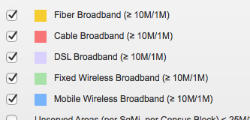
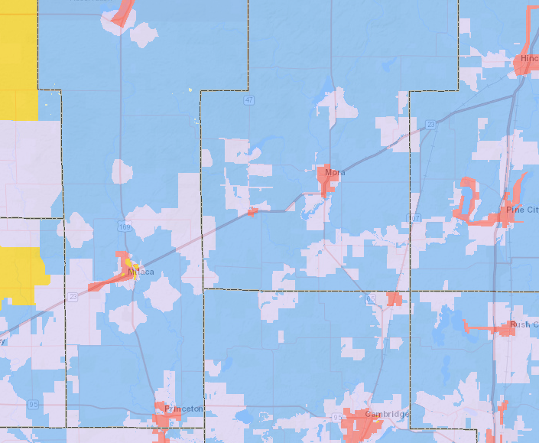
M = Megabits per second
The federal government, through the Federal Communication Commission, has set 25 Megabits per second (Mbps) download/3 Mbps upload as the minimum standard for broadband services. Many consumers in rural areas do not have access to services that meet this standard. Even with lower speeds, students will still be able to successfully accomplish their homework and parents can access the parent portal.

Speeds needed for common online tasks, according to the Federal Communication Commission (https://www.fcc.gov/reports-research/guides/broadband-speed-guide):

Email/Basic browsing | 1 Mbps download
Video streaming | 4 Mbps for standard video or 5-8 Mbps for high definition video
Music streaming | .5 Mbps
Video web conferencing | 1.5 Mbps
Large uploads/downloads | 50 Mbps download/ 25 Mbps upload for high definition files
Average student use | 5-25 Mbps

Low-cost plans
Broadband is an essential tool for all families, especially those with children in school, and some providers have created low-cost plans that make it easier for most families to subscribe. Below is a table that summarizes some of these plans. If your existing or prospective provider is not listed, please go to their web site or contact them to see if they have a low-cost plan.

Provider* | Program Name | Program Details | Web Site
CenturyLink | Lifeline | Discount of $9.25 per month on Internet services. | http://www.centurylink.com/aboutus/community/community-development/lifeline.html
Comcast | Internet Essentials | $9.95 per month for up to 15 Mbps; $149.99 for a new computer; online learning center. | www.internetessentials.com
Frontier | Lifeline | Discount of $9.25 per month on Internet services | https://frontier.com/resources/discountprograms/lifelineprogram/minnesota
Mediacom | Connect2compete | $9.95 per month for up to 10 Mbps | http://mediacomc2c.com/apply.aspx
Midco | Lifeline | Discount of $9.25 per month on Internet services. | https://www.midco.com/lifeline/
PCs for People | PCs for People | Refurbished computers at no or low cost. Wireless service as low as $10 per month over the Sprint network. | www.pcsforpeople.com
*The listing of companies in this guide does not constitute a recommendation or endorsement of their services. Companies wishing to be included in this listing should contact the school district. Prices and federal programs subject to change.

Public Access
We recognize that some families will not be able to get broadband and/or lack computers at their homes.

In our community, you can get access to both equipment and Internet services at the following locations. With some of these locations, the wi-fi connection reaches outside for 24-hour access.

[Fill out columns based on your community]
Location | Hours | What’s available | Device checkout | Limitations
High School | ?? | Computer lab, wireless wi-fi connections | No | Filtered content, no access to Facebook, etc.
Library | ?? | Xx computers; wi-fi | Cellular wi-fi hotspots | Time limit?
YMCA?
Boys and Girls Club?
Etc.

Families might also find wi-fi connections at local businesses, such as coffee shops, restaurants, tourism attractions, etc.

Questions
If you have questions or comments about Internet service available to you at your home or public access points, contact NAME at NUMBER/EMAIL.

