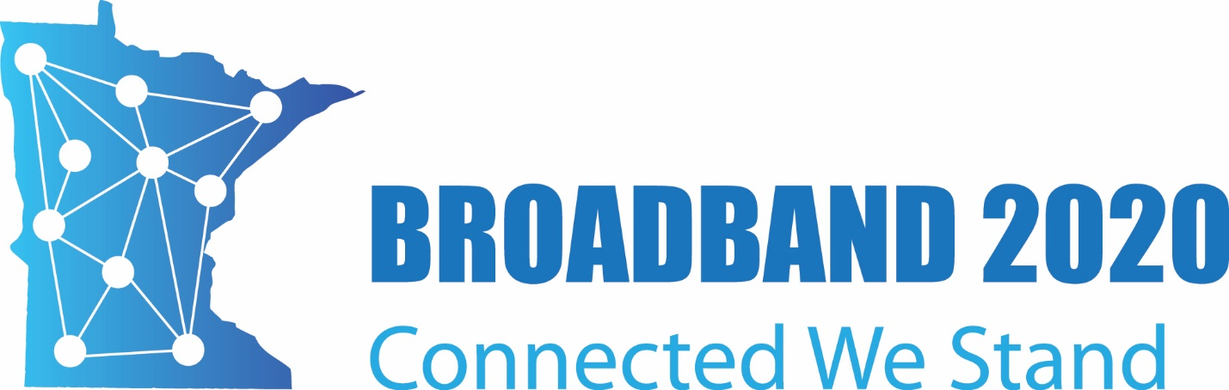

Trivia Night!
Round 1

- What year did Minnesota become a state?
- What is the Minnesota state Fruit?
- Where is the largest Paul Bunyan Statue?
- How old would Prince be today?
- Of these five useful things, which one was not invented in Minnesota?
  - The pop-up toaster
  - Scotch tape
  - the beverage vending machine
  - the paint roller
  - the handled shopping bag.

